MySQL Question for Dairy Dataset

Q1: Total revenue generated by each product
select Product_Name, round(sum(Approx_Total_RevenueINR),2) as Revenue from dairy_dataset
group by Product_Name
order by revenue desc;

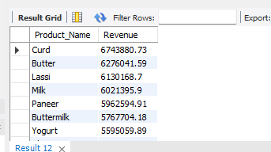
Q2: Give Brand with the highest total revenue
select Brand, round(sum(Approx_Total_RevenueINR),2) as Revenue from dairy_dataset
group by Brand
order by Revenue desc limit 1;

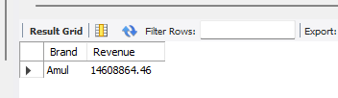

Q3: Give Monthly revenue trend across all products
select monthname(Date_), round(sum(Approx_Total_RevenueINR),2) as Revenue from dairy_dataset group by monthname(Date_)
order by monthname(Date_) desc;

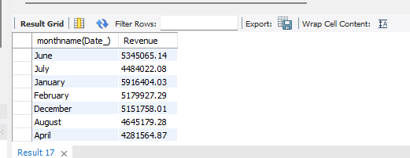

Q4: Products below the minimum stock threshold
select Product_Name, Quantity_in_Stock_liters, Minimum_Stock_Threshold_liters from dairy_dataset where Minimum_Stock_Threshold_liters > Quantity_in_Stock_liters;

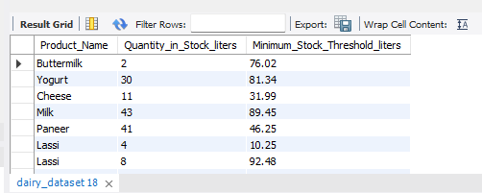

Q5: Total reorder quantity required per product
select Product_Name,Quantity_in_Stock_liters,Reorder_Quantity_liters from dairy_dataset where Reorder_Quantity_liters>Quantity_in_Stock_liters;

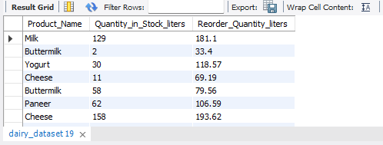

Q6: Which sales channel generates the most revenue
select Sales_Channel, round(sum(Approx_Total_RevenueINR),2) from dairy_dataset
group by Sales_Channel;

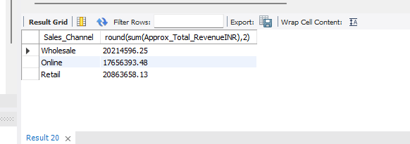

Q7: Top 5 customer locations by purchase volume
select Customer_Location, sum(Quantity_Sold_liters) as purchase_volume from dairy_dataset
group by Customer_Location
order by purchase_volume desc limit 5;

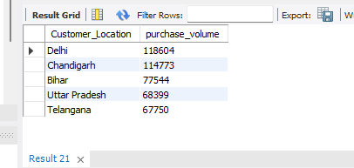

Q8: Average selling price per product
select Product_Name, round(avg(Price_per_Unit_sold),2) as average from dairy_dataset
group by Product_Name
order by average desc;

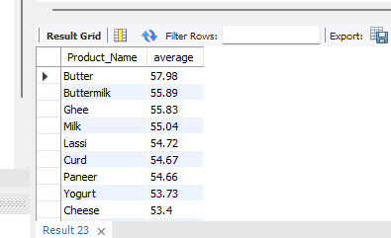

Q9: Compare selling price with listed price
select Product_Name, Price_per_Unit, Price_per_Unit_sold, round(Price_per_Unit-Price_per_Unit_sold) from dairy_dataset;

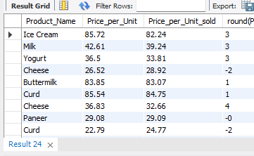

Q10: Products with less than 10 days shelf life remaining
select Product_Name, Shelf_Life_days from dairy_dataset where Shelf_Life_days<10;

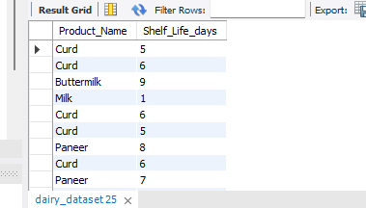

Q11: Average shelf life by product category
select Brand, avg(Shelf_Life_days) as Average_shelf_life from dairy_dataset
group by Brand
order by Average_shelf_life desc ;

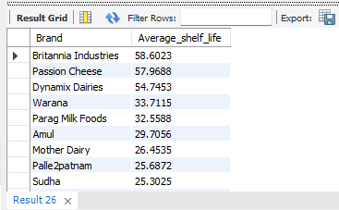

Q12: Average number of cows per farm size category
select Farm_Size, avg(Number_of_Cows) from dairy_dataset
group by Farm_Size;

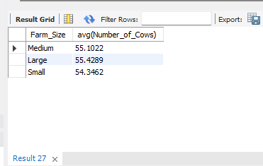

Q13: Location with the largest total land area
select Location, sum(Total_Land_area_acres) from dairy_dataset
group by Location
order by sum(Total_Land_area_acres) desc;

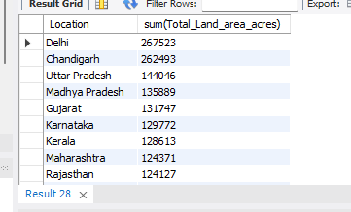

Q14: Top 3 locations by average production quantity
select Location, round(avg(Quantity_liters),2) as average_prod_quantity from dairy_dataset
group by Location
order by average_prod_quantity desc limit 3;

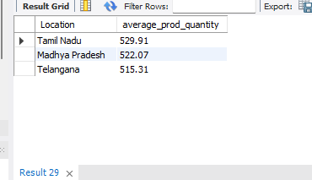

Q15: Calculate profit for each product
select Product_Name, round(Price_per_Unit-Price_per_Unit_sold,2) as profit from dairy_dataset ;

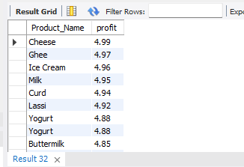

Q16: Most profitable brand overall
select Brand, round(Price_per_Unit_sold-Price_per_Unit) as profit from dairy_dataset
order by profit desc limit 1;

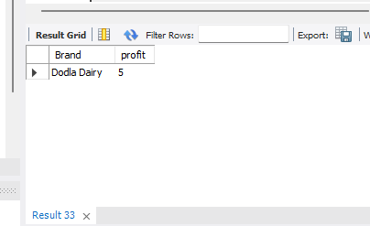

Q17: Yearly revenue growth
select year(Date_), round(sum(Approx_Total_RevenueINR),2) as yearly_revenue_growth from dairy_dataset
group by year(Date_)
order by yearly_revenue_growth desc ;

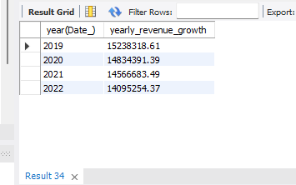

Q18: Best-selling product each year
select Product_Name, year(Date_), sum(Quantity_Sold_liters) from dairy_dataset
group by Product_Name, year(Date_);

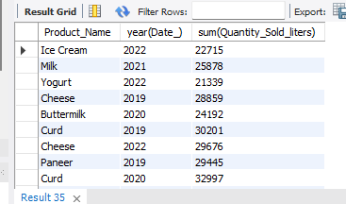

Q19: Products that need immediate restock
select Product_Name, Quantity_in_Stock_liters, Minimum_Stock_Threshold_liters from dairy_dataset where Minimum_Stock_Threshold_liters > Quantity_in_Stock_liters;

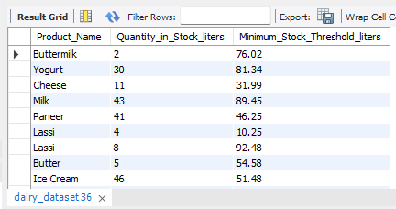

Q20: Identify expired products still in stock
select Product_Name, Quantity_in_Stock_liters, Date_, Expiration_Date from dairy_dataset where Date_>Expiration_Date ;

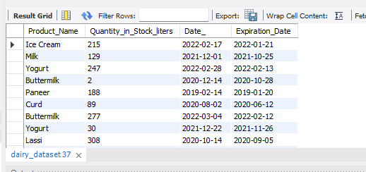

Q21: Average shelf life per brand
select Brand, avg(Shelf_Life_days) from dairy_dataset
group by Brand;

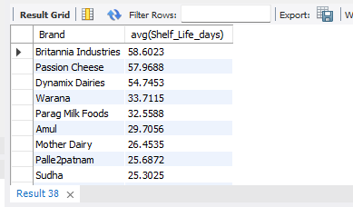

Q22: Most popular product in each customer location
select Product_Name, Customer_Location, count(Quantity_Sold_liters) from dairy_dataset
group by Customer_Location, Product_Name;

